1. Numpy operations like addition, subtraction, multiplication, division, etc.

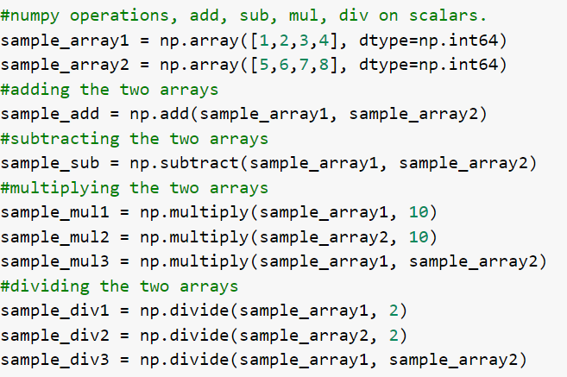

1. Print the results from the above operations

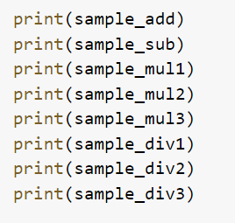

1. The output will show the results from the above operations

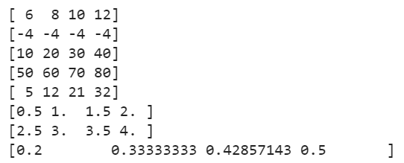

1. More numpy operations, like cross product, dot product and matrix multiplication.

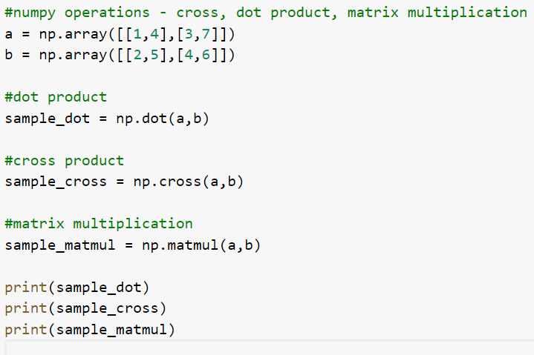



1. The output will show the result from the above operation.

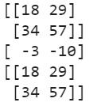

1. More operations like sqrt on the same sample arrays a and b.

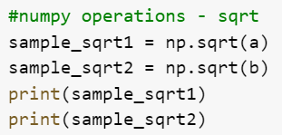

1. The output will show the sqrt of each of the arrays.

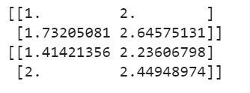

1. Flattening the 3x3 identity matrix.

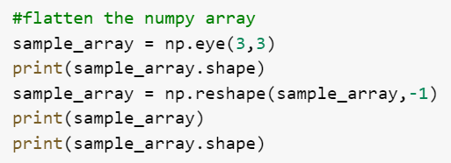

1. The output will show the flattened array, and the shape of the array before and after flattening.

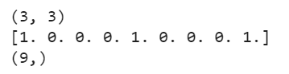

1. Numpy datetime, to work with the datetime format.

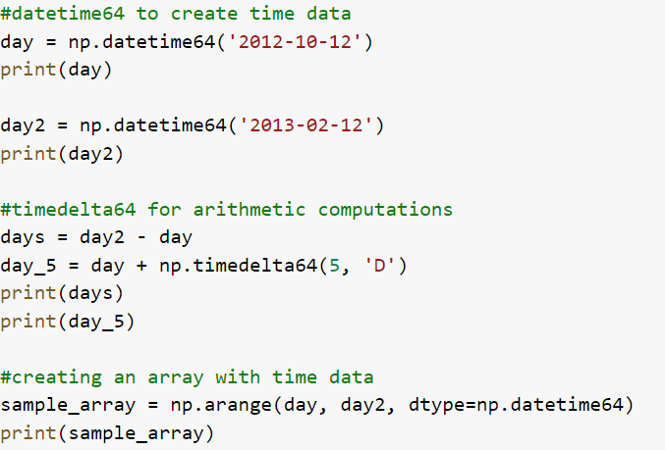

1. Stacking operations using numpy

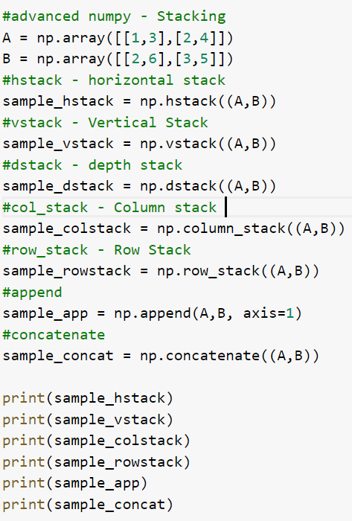

1. The output shows the stacking operations from the above code.

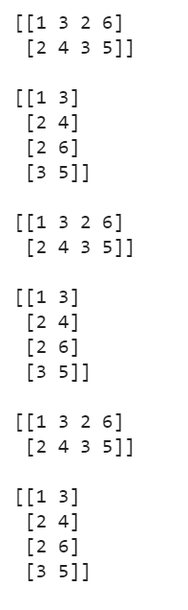

1. Numpy splitting operations

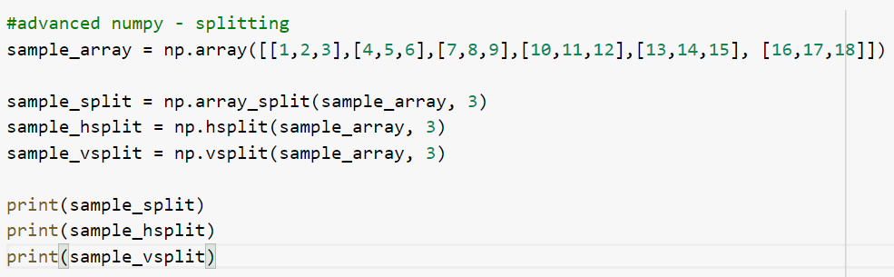

1. The output will show the splitting operations in the above code.

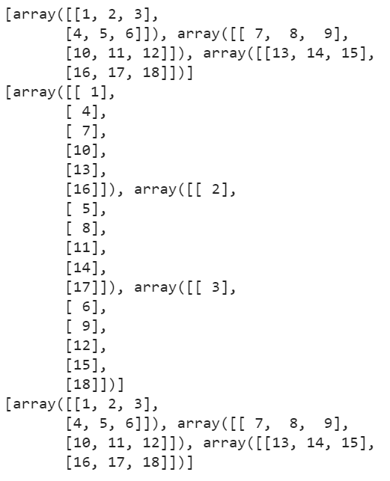

1. Linear algebra using numpy in python

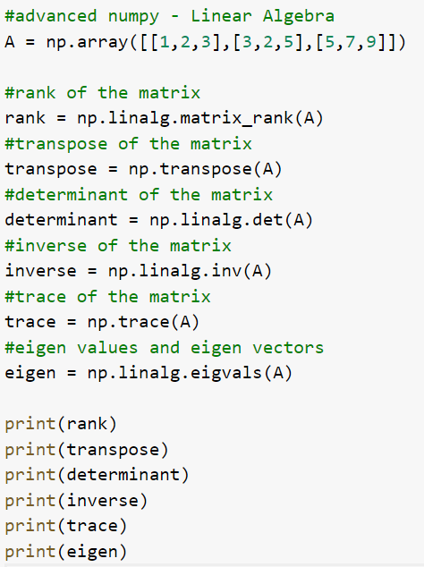

1. The above code shows the rank, transpose, determinant, inverse, trace and eigen values of the given matrix.

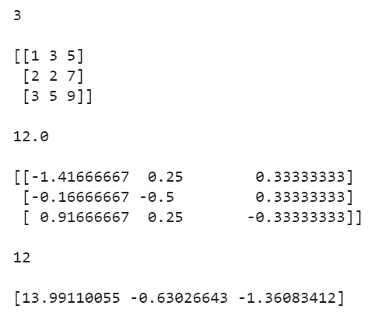

1. Correlation between two numpy array, using corrcoeff()

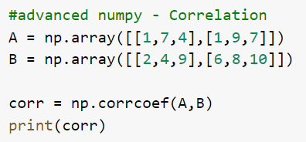

1. The output shows the correlation between the arrays, A and B.

